Ideation Phase
Brainstorm & Idea Prioritization

Date | 29 September 2026
Team ID | SWTID-2026-1757
Project Name | AI StudyBuddy
Maximum Marks | 4 Marks

Brainstorm & Idea Prioritization :
The brainstorming process identified various ideas to improve students’ learning experiences, including personalized study plans, AI-based recommendations, task reminders, progress tracking, quiz generation, and weak-topic identification. These ideas were evaluated based on usefulness, feasibility, student needs, and implementation effort. The most valuable features were prioritized to create an effective AI StudyBuddy system that helps students manage their time, study efficiently, monitor progress, and achieve their academic goals.

Step-1: Team Gathering, Collaboration and Select the Problem Statement
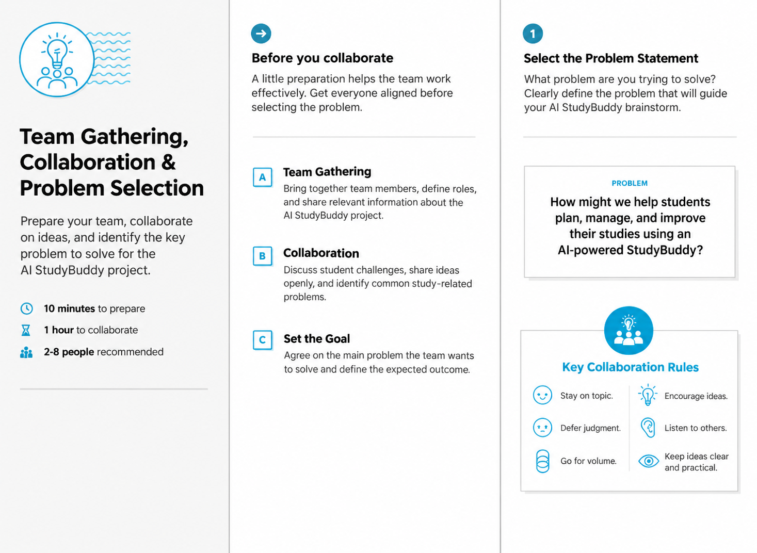

Step-2: Brainstorm, Idea Listing and Grouping
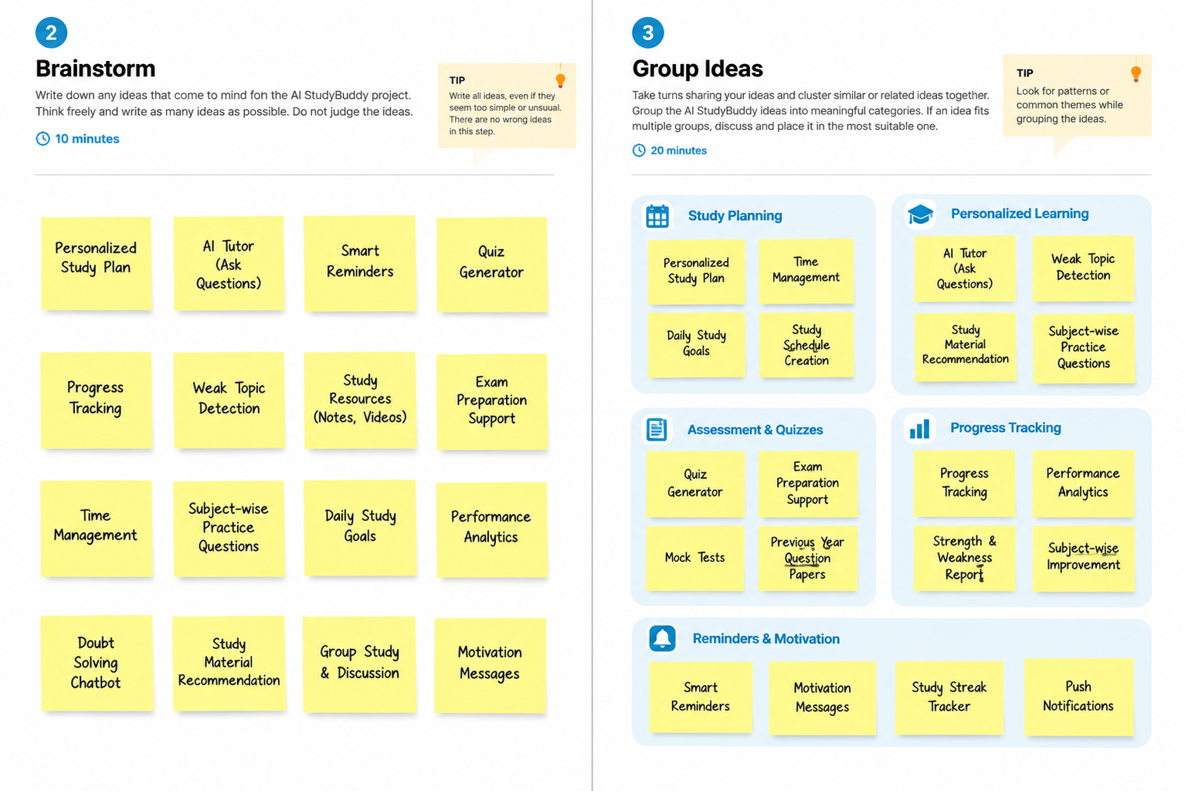

Step-3: Idea Prioritization
